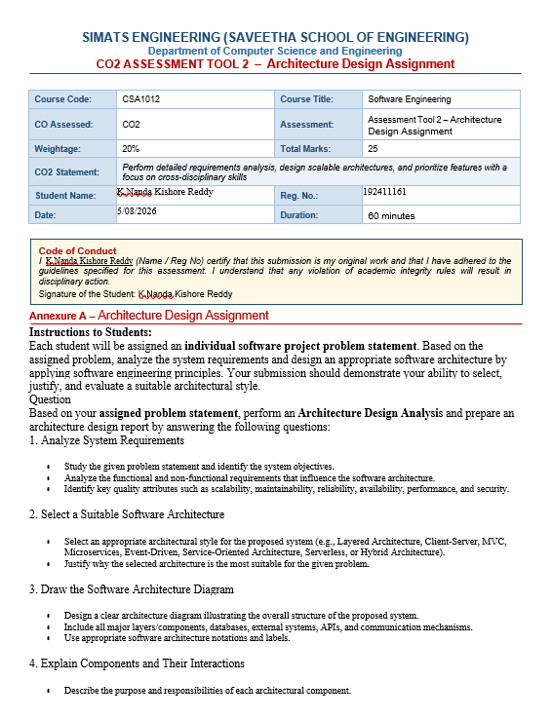
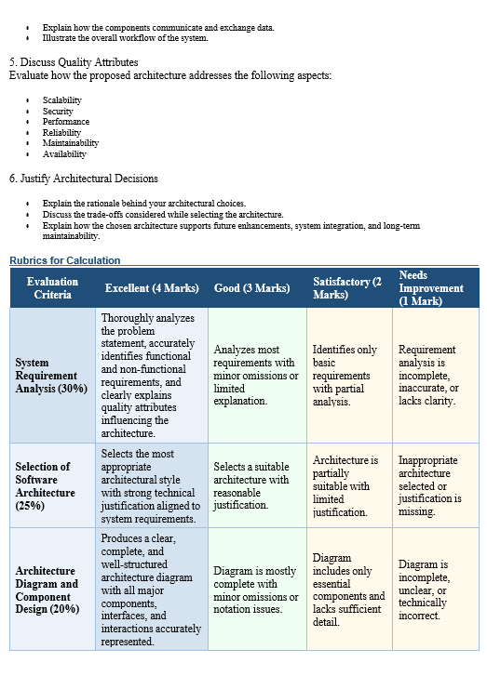
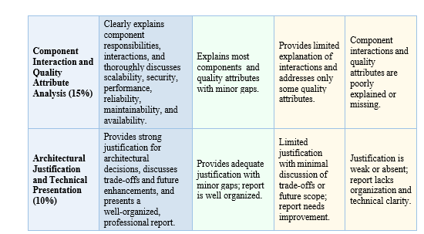

Table of Contents
No. | Contents | Page No.
1 | Introduction | 1
2 | System Requirements Analysis | 2
2.1 | System Objectives | 2
2.2 | Functional Requirements | 3
2.3 | Non-Functional Requirements | 4
2.4 | Key Quality Attributes | 5
3 | Selection of Software Architecture | 6
3.1 | Selected Architectural Style | 6
3.2 | Justification of Architecture Selection | 7
4 | Software Architecture Design | 8
4.1 | Software Architecture Diagram | 8
4.2 | Architectural Components | 9
4.3 | Component Interactions | 11
4.4 | System Workflow | 12
5 | Quality Attribute Evaluation | 13
5.1 | Scalability | 13
5.2 | Security | 14
5.3 | Performance | 15
5.4 | Reliability | 16
5.5 | Maintainability | 17
5.6 | Availability | 18
6 | Justification of Architectural Decisions | 19
6.1 | Rationale for Choosing Hybrid Architecture | 19
6.2 | Architectural Trade-offs | 20
6.3 | Future Enhancements | 21
7 | Conclusion | 22
8 | References | 23

Architecture Design Report
Intelligent Airport Baggage Tracking and Logistics Management Platform
1. Analyse System Requirements
1.1 System Objectives
The Intelligent Airport Baggage Tracking and Logistics Management Platform aims to:
- Track passenger baggage in real time throughout the airport.
- Reduce baggage loss, theft, and mishandling.
- Improve baggage handling efficiency.
- Provide passengers with live baggage status updates.
- Enable airport staff to monitor baggage movement.
- Support airlines in managing baggage operations.
- Generate operational reports and analytics.
- Integrate with airport systems, airline systems, RFID scanners, barcode readers, and IoT sensors.

1.2 Functional Requirements
Passenger Module
- Passenger registration and login
- View baggage status
- Receive baggage notifications
- Report lost baggage
Airport Staff Module
- Scan baggage using RFID/Barcode
- Update baggage location
- Manage baggage transfer
- Search baggage records
Airline Module
- Assign baggage to flights
- Monitor baggage loading/unloading
- Handle delayed baggage
Admin Module
- User management
- Airport management
- Device management
- Report generation
- System monitoring
Tracking Module
- Real-time baggage tracking
- GPS/RFID data processing
- Location history
Notification Module
- SMS alerts
- Email notifications
- Mobile app push notifications
Analytics Module
- Delay analysis
- Lost baggage reports
- Performance dashboards
1.3 Non-Functional Requirements
Performance
- Process thousands of baggage scans per minute.
- Real-time location updates.
Scalability
- Support multiple airports.
- Handle millions of baggage records.
Availability
- System available 24×7.
Reliability
- No loss of tracking information.
- Fault-tolerant operations.
Security
- Secure user authentication.
- Data encryption.
- Access control.
Maintainability
- Easy feature updates.
- Modular architecture.
Interoperability
- Integration with airline APIs.
- Integration with airport management systems.

1.4 Key Quality Attributes
Quality Attribute | Importance
Scalability | Very High
Performance | Very High
Availability | High
Reliability | High
Maintainability | High
Security | Very High

2. Select Suitable Software Architecture
Selected Architecture
Hybrid Architecture
Combining:
- Microservices Architecture
- Event-Driven Architecture
- Layered Architecture

Why Hybrid Architecture?
Airport baggage management requires:
- Real-time processing
- Multiple independent services
- High scalability
- Continuous communication between devices
- Easy integration
Microservices alone cannot efficiently process continuous RFID events.
Event-driven architecture handles real-time baggage movement.
Layered architecture organizes business logic.
Therefore, a Hybrid Architecture is the best choice.

Main Microservices
- User Service
- Authentication Service
- Baggage Tracking Service
- Flight Service
- Notification Service
- Analytics Service
- Reporting Service
- Device Integration Service

3. Software Architecture Diagram
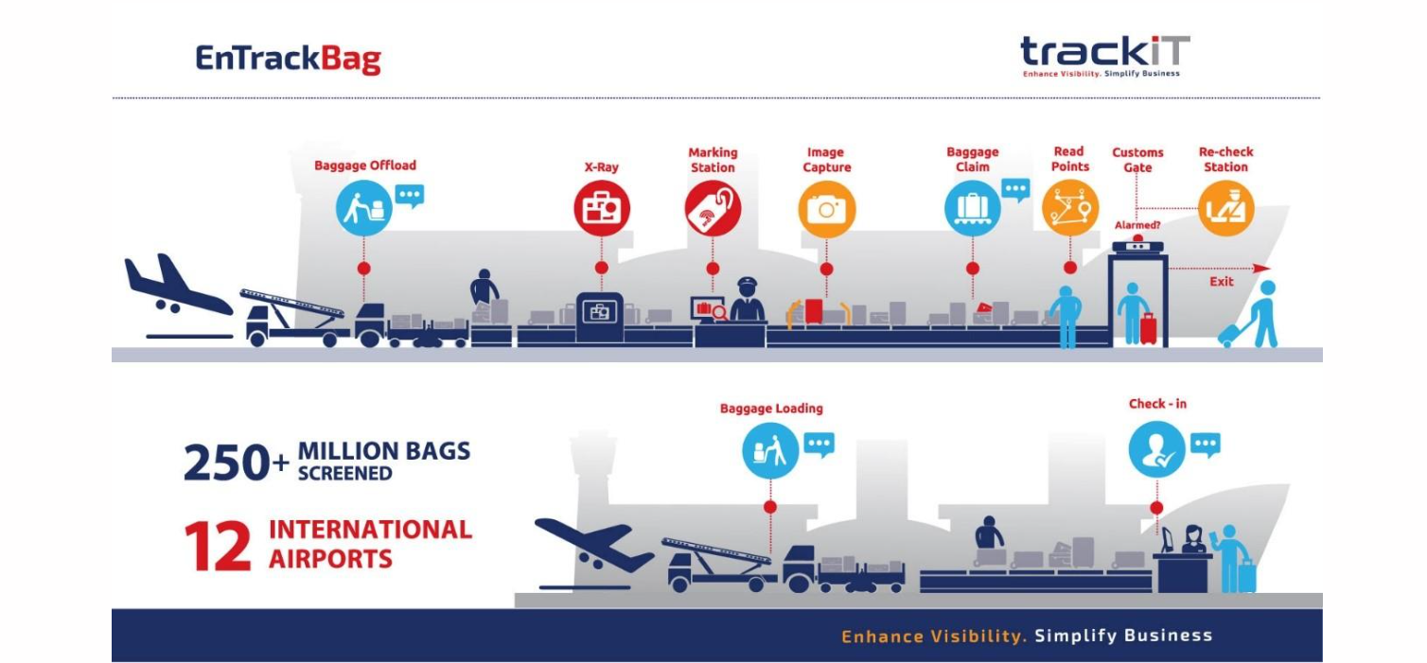

External Systems
• Airline Reservation System
• Airport Management System
• SMS Gateway
• Email Service
• Payment Gateway (if required)

4. Components and Their Interactions
4.1 API Gateway
Responsibilities
- Single entry point
- Authentication
- Load balancing
- Request routing

4.2 Authentication Service
Responsibilities
- User login
- JWT token generation
- Role-based authorization

4.3 User Service
Responsibilities
- Passenger management
- Airport staff management
- Airline staff management

4.4 Baggage Tracking Service
Responsibilities
- Receive RFID scan events
- Update baggage location
- Maintain baggage history
- Detect missing baggage

4.5 Flight Service
Responsibilities
- Flight schedules
- Baggage assignment
- Loading and unloading

4.6 Device Integration Service
Responsibilities
- Receive RFID scanner data
- Receive barcode scans
- Validate device information
- Send events to Event Bus

4.7 Notification Service
Responsibilities
- Send SMS
- Send Email
- Push notifications
Example:
Your baggage has arrived at Carousel 5.

4.8 Analytics Service
Responsibilities
- Predict baggage delays
- Generate statistics
- Operational dashboards

4.9 Reporting Service
Responsibilities
- Daily reports
- Lost baggage reports
- Airport performance reports

Component Communication
Synchronous Communication
- REST APIs
- HTTPS
Used for:
- Login
- User requests
- Flight information

Asynchronous Communication
- Kafka/RabbitMQ Event Bus
Used for:
- RFID events
- Notifications
- Analytics
- Logging
Overall Workflow
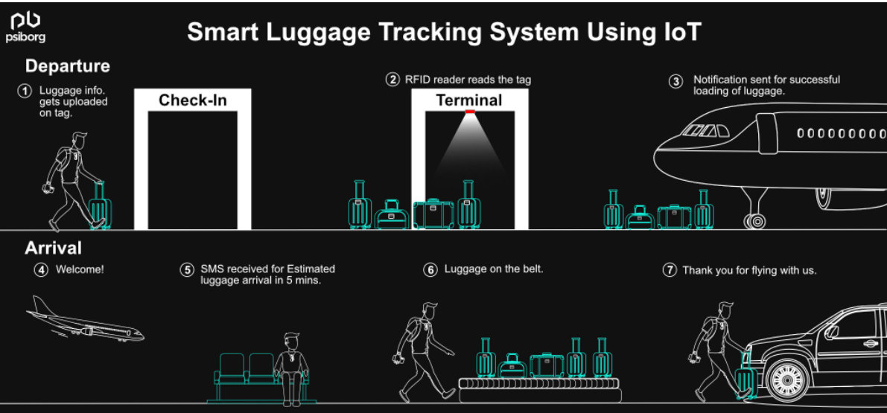

5. Quality Attributes
5.1 Scalability
How achieved:
- Independent microservices
- Load balancing
- Container deployment
- Horizontal scaling
Result:
Supports multiple airports and millions of baggage records.

5.2 Security
Methods:
- JWT Authentication
- HTTPS
- Role-Based Access Control (RBAC)
- OAuth 2.0
- Database encryption
- Audit logs
Result:
Secure access and protected passenger data.

5.3 Performance
Methods:
- Event-driven messaging
- Distributed services
- Caching
- Optimized databases
- Asynchronous processing
Result:
Real-time baggage tracking with minimal delay.

5.4 Reliability
Methods:
- Message queues
- Retry mechanisms
- Database replication
- Automatic backups
- Service monitoring
Result:
Minimal data loss and high operational reliability.

5.5 Maintainability
Methods:
- Independent services
- Modular code
- Clear APIs
- Continuous Integration/Continuous Deployment (CI/CD)
Result:
Easy maintenance and future upgrades.

5.6 Availability
Methods:
- Cloud deployment
- Multiple application servers
- Load balancers
- Database replication
- Automatic failover
Result:
24/7 uninterrupted operation.

6. Justification of Architectural Decisions
Why Hybrid Architecture?
The baggage management platform must process continuous streams of RFID events while supporting thousands of simultaneous users across multiple airports. A Hybrid Architecture combining Microservices, Event-Driven, and Layered Architecture provides the flexibility and scalability needed for this environment.
Advantages
- Independent deployment of services
- High scalability
- Fault isolation
- Real-time event processing
- Easy integration with external systems
- Better maintainability
- Improved reliability
- Supports cloud deployment

Trade-offs
Advantage | Trade-off
High scalability | Higher infrastructure cost
Independent deployment | More complex service management
Fault isolation | Requires monitoring and orchestration
Event-driven processing | Event ordering and debugging can be more challenging
Modular development | Increased inter-service communication overhead

Future Enhancements
The proposed architecture can easily support future features such as:
- AI-based baggage delay prediction
- Machine learning for route optimization
- Facial recognition for baggage collection
- Smart baggage lockers
- Drone-assisted baggage transportation
- Integration with additional airline systems
- Mobile wallet and digital boarding pass integration
- Multi-airport and international baggage tracking
- IoT-based predictive maintenance for baggage handling equipment

Conclusion
A Hybrid Architecture (Microservices + Event-Driven + Layered) is the most suitable choice for the Intelligent Airport Baggage Tracking and Logistics Management Platform. It provides real-time event processing, high scalability, strong security, reliability, maintainability, and seamless integration with airport devices and external airline systems. This architecture also supports future expansion and long-term sustainability, making it well-suited for modern smart airport operations.

References
- Bass, L., Clements, P., & Kasman, R. (2022). Software architecture in practice (4th ed.). Addison-Wesley.
- Fowler, M. (2018). Patterns of enterprise application architecture. Addison-Wesley.
- Gamma, E., Helm, R., Johnson, R., & Vlassises, J. (1994). Design patterns: Elements of reusable object-oriented software. Addison-Wesley.
- Newman, S. (2021). Building microservices: Designing fine-grained systems (2nd ed.). O'Reilly Media.
- Richards, M., & Ford, N. (2020). Fundamentals of software architecture: An engineering approach. O'Reilly Media.
- Richardson, C. (2019). Microservices patterns: With examples in Java. Manning Publications.
- Sommerville, I. (2016). Software engineering (10th ed.). Pearson.

